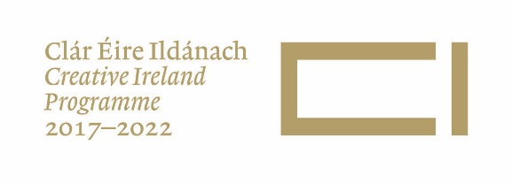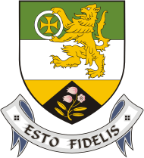

Offaly County Council
Creative Ireland Community Project – call for applications 2019

- Introduction
Offaly County Council, with financial support from Creative Ireland, seeks to award grants of up to €5,000 to communities and artists working together to explore and present aspects of Offaly’s heritage.

Heritage can include any of the following monuments, archaeological objects, heritage objects including archives, architectural heritage, flora, fauna, wildlife habitats, landscapes, geology, heritage gardens and parks, inland waterways, folklore and local history.

Arts can include any creative or interpretative expression (whether traditional or contemporary) in whatever art form, including; visual arts, theatre, literature, music, dance, opera, film, circus and architecture, and includes any medium within those art forms, ‘for the purpose of stimulating public interest and engagement in the arts, promoting knowledge, appreciation and practice of the arts or improving standards in the arts.’

This is a multi-disciplinary commission and applications are invited from communities that may work with visual artists, film makers, musicians, writers, theatre practitioners, choreographers, dance makers, new media and more.

- Context
Creative Ireland is the Government’s Legacy Programme for Ireland 2016. The 2018-22 five-year Culture and Creativity Plan was adopted by Offaly County Council in December 2017 and can be viewed on www.offaly.ie/heritage news and events.

The Creative Ireland Programme has collaboration at its heart – between central and local government, between heritage, arts, culture and industry, between artists, communities and policy makers– to facilitate a culture of creativity. This project, drawing together heritage, arts, communities and artists, ideally fits in with Pillar Two of Creative Ireland, Enabling Creativity in Every Community. See http://creative.ireland.ie/ . There is a vibrant library network in the county which can be utilised as a resource as part of this call.

- Finance
- The value of this commission is up to €5,000 per project, inclusive of all costs including any fees, transport, expenses, materials, insurance, services required and any VAT that falls due on costs.
- All groups/ individuals awarded must have a valid Tax Clearance Number/access number, a bank account (not credit union) in the name of the group and an e-mail contact.
- A detailed breakdown of costs associated with all elements of the project should be submitted.
- This grant will be awarded on the basis of a fixed price, and as such, all costs must be quoted (and clearly indicated) as a fixed price in Euro. No other amount over and above the negotiated amount will be paid.

- Timetable
- The closing date for receipt of submissions is noon on Friday 26 April 2019
- Successful communities /artists will be notified by early May. The project must be completed with paper work submitted by the end of October 2019.

- Selection Process
- The selection panel will include representatives of the Offaly Culture Team.
- We reserve the right to ask for clarity of information or to reconsider elements such as delivery procedures, budget, time schedule or any such factors deemed necessary for a successful outcome.
- We reserve the right not to proceed with any proposal under this invitation and consider other appropriate courses of action.
- The decision of the selection panel is final.

- Assessment Criteria
- This is a competitive process and your proposal will be assessed using the following criteria;
  - Community Reach – estimate of target group and level of contact. (25 marks)
  - Demonstrating the dynamic of bringing an artistic approach to explore and communicate an aspect of arts or heritage. (25 marks)
  - Artistic quality, creativity and originality of the proposal presented, on a standalone basis, with reference to other competing applicants and in relation to the brief. (25 marks)
  - Feasibility of the commission, such as time/budget/ and the track record of the community / artist to deliver (25 marks)

- Contract Conditions
- All work activities must be carried out in accordance with Health and Safety Guidelines and Acts.
- The successful community groups/ artists will be required to provide regular updates to Offaly County Council.
- Offaly County Council will not be liable for any other expenses incurred by the community group/artists.
- Offaly County Council undertakes to use their best endeavours to protect confidential and commercially sensitive information provided by you in this application subject to the Council’s obligations under Law and including the Freedom of Information Act, 2014. Should you wish that any of the information supplied by you should not be disclosed because of its sensitivity, you should, when providing the information, identify same and specify reasons for its sensitivity. If your application is successful the price will, as a matter of course, be available to the public outside of the scope of F.O.I. legislation. Offaly County Council will consult with you about the release of confidential and commercially sensitive information before making decisions on any F.O.I. request received. If, having considered your views, Offaly County Council is of the opinion that the information should be released in the public interest; you will have the option of appealing the decision to the Information Commissioner. Please note that in the event that no information is identified by you as sensitive, with supporting reasons, then it is likely to be released in response to a request under the Freedom of Information Acts.
- Offaly County Council’s own Child Protection Policy requires that any project involving young people has the appropriate Child Protection Policies and/or certificates in place. We are unable to fund projects that do not have this assurance, therefore, it is the organisations responsibility to ensure that any person hired by them has the appropriate Child Protection Training.

- How to Apply
Please submit by email or hard copy. If hard copy is submitted, please include a digital copy of all documents submitted, on CD or USB. Please note if submitting by email the total maximum size for emails is 5MB. Larger files can be submitted by requesting a Sharefile link from creativeculture@offalycoco.ie It is the responsibility of the applicant to ensure that emails are received.
The proposal should include:
  - Details of the proposal including forms of engagement between the artist/s with the local community (max 1000 words);
  - Indication of how you propose to use the budget (for the purposes of establishing feasibility) including inter alia headings such as artist’s fee and any other fees, other resources needed, transport/travel/ accommodation costs, production costs.
  - Timescale breakdown – research / community contact / production / delivery
  - Sample of work by artist/s and their CVs

Please address your application to
Creative Ireland Community Project, Offaly County Council , Áras an Chontae, Charleville Road, Tullamore, County Offaly
Or email creativeculture@offalycoco.ie (max size per email 5MB)

For further enquires please contact 057 9346839 or email creativeculture@offalycoco.ie

Offaly County Council with funding from the Creative Ireland Programme
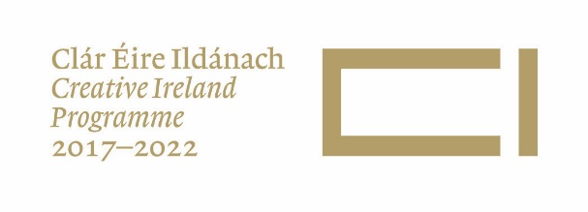

Offaly County Council
Creative Ireland Community Summary Sheet 2019
Please submit the following with the full submission requirements as detailed in the project brief.

Community and artist’s Name
Contact person for community group
Artistic Discipline
Postal Address
Phone number(s)
Website
Email
Title of proposal
Concept of the Proposal (summary)
Signature of Artist
Signature of Community
Date
Bank Account/ sort code/
IBAN number
Tax Clearance Number

