Offaly PPN Community Wellbeing Consultation

Please complete the Online Questionnaire:

We need your contribution.

This is your opportunity to input into the future of your Community.

See below the different Areas, this is a follow up to the Consultations held in each of the MD’s.
Why are we running this consultation?
The Offaly Public Participation Network(PPN) is working with its members to produce a shared vision for the future wellbeing of the county. This vision will be used to inform the work of the PPN and its representatives. Community wellbeing combines a number of issues such as health, social and community development, the environment and public participation. We want to hear your organisation’s or group’s ambitions and aspirations for our community around these issues. Your responses will be collected and incorporated into a Draft Vision for Community Wellbeing for Offaly PPN. This draft Vision will be made available for feedback from all PPN member groups before being finalized and published.
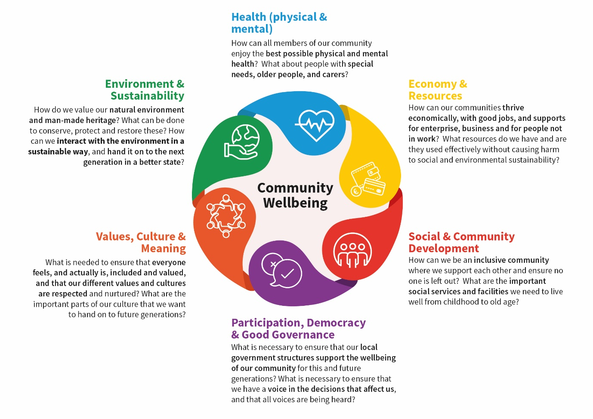

These are the Questions you will be asked to consider.
1: Social & community developmenT
How can we be an inclusive community where we support each other and ensure no one is left out? What are the important social services and facilities we need to live well from childhood to old age?
Question: Describe what you want future generations to have in relation to Social & Community Development
(if you are describing more than one issue or topic in your response, please separate them with a full stop)
What is necessary to ensure that our local government structures support the wellbeing of our community for this and future generations? What is necessary to ensure that we have a voice in the decisions that affect us and that all voices are being heard?
Question: Describe what you want future generations to have in relation to Participation, Democracy & Good Governance.
(if you are including more than one issue or topic in your response, please separate these with a full stop.)
2: articipation, democracy & good governancE
How can all members of our community enjoy the best possible physical and mental health? What about people with special needs, older people, and carers?
Question: Describe what you want future generations to have in relation to Health (Physical and Mental).
(If you are including more than one issue or topic in your response, please separate these with a full stop.)
3: Health (physical & mental)

4: economy, work & resources
How can our communities thrive economically, with good jobs, and supports for enterprise, business and for people not in work? What resources do we have and are they used effectively and sustainably without causing harm to social and environmental sustainability?
Question: Describe what you want future generations to have in relation to Economy, Work and Resources.
(If you are including more than one issue or topic in your response, please separate these with a full stop.)
How do we value our natural environment and man-made heritage? What can be done to conserve, protect and restore these? How can we interact with the environment in a sustainable way, and hand it on to the next generation in a better state?
Question: Describe what you want future generations to have in relation to Environment and Sustainability.
(If you are including more than one issue or topic in your response, please separate these with a full stop)
5: environment & sustainability
6: Values, Culture & Meaning
What is needed to ensure that everyone both feels, and actually is, included and valued, and that our different values and cultures are respected and nurtured? What are the important parts of our culture that we want to hand on to future generations?
Question: Describe what you want future generations to have in relation to Values, Culture and Meaning.
(if you are including more than one issue or topic in your response, please separate these with a full stop.)

Now take the survey: https://www.surveymonkey.com/r/F5LB5L5

Data Protection Statement

Before filling out the consultation, we need you to read the following data protection statement. It explains what we do with the information you provide us.

In accordance with our obligations under Data Protection legislation, we will keep your personal data, including any data that may be capable of identifying you either on its own or when used with other data in our possession, safe and secure and will not disclose it to anyone outside of the Offaly PPN and our external facilitators who are supporting us in our work.

Your personal data will be held for no longer than is reasonably necessary for us to complete our work. On completion of this work, your personal data such as email address, will be retained for 12 months in accordance with our data protection policy. Should you want us to remove your personal data from our database, please contact Bridie or Sharon at ppn@offalycoco.ie

By completing the form, you consent to the use by Offaly PPN and our external facilitators using your personal data in the manner set out above.

How to respond to this consultation This consultation aims to understand what your organisation considers to be the important factors for the future wellbeing of your community under the six wellbeing themes below.

