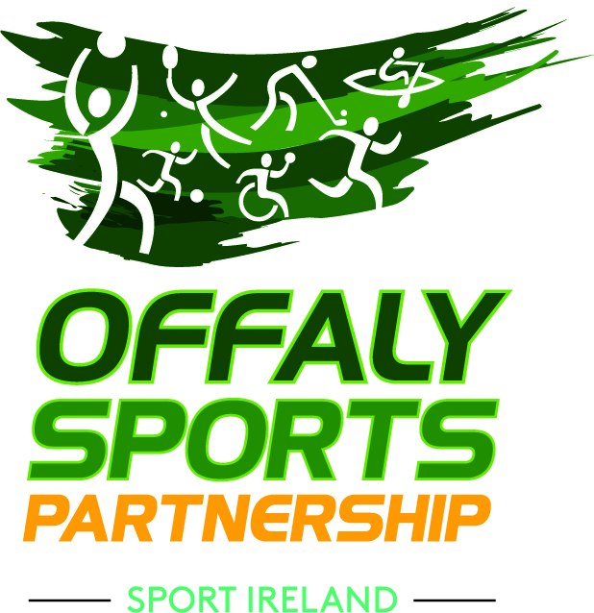
Application Form for Coaching Qualifications Programme for Young Women 2019
Name (BLOCK LETTERS):
Date of Birth:
Address:
Mobile no:
Email (Please print clearly):

Background in sport as a participant/volunteer.

Any relevant qualifications:

Please tell us why you would be suited to this course and why you are interested in it.
Elective modules: Please rank in order any sport you would be interested in learning to coach. Rank 1 for the sport you would be most interested in, 2 for the next sport etc. If not interested in training in a particular sport tick not interested.
Sport | Rank (1-favourite, 2- next favourite etc) | Not Interested
Badminton
Basketball
Boxing
Cycling
Handball
Hockey
Netball
Pitch & Putt
Tennis
Spikeball/Volleyball

Would you have an interest in training to be a referee/official in a sport (If yes please indicate which sport)

Closing date for application is Thursday 18th April.
Programme is limited to a maximum of 18 participants. Full commitment to attend 4 days per week will be required. Based on the level of demand Offaly Sport Partnership may draw up a shortlist. Short listed candidates will be required to attend an interview or short meeting prior to being offered a place. For the purpose of the work experience module successful applicants will be subject to Garda Vetting.

I _________________________ (full name) the undersigned, wish to apply for the Community Coaching Course for Young People.
Signed: _________________________ Date: _________________________

Signed: _________________________ Date: _________________________
(Parent/Guardian if under 18):


